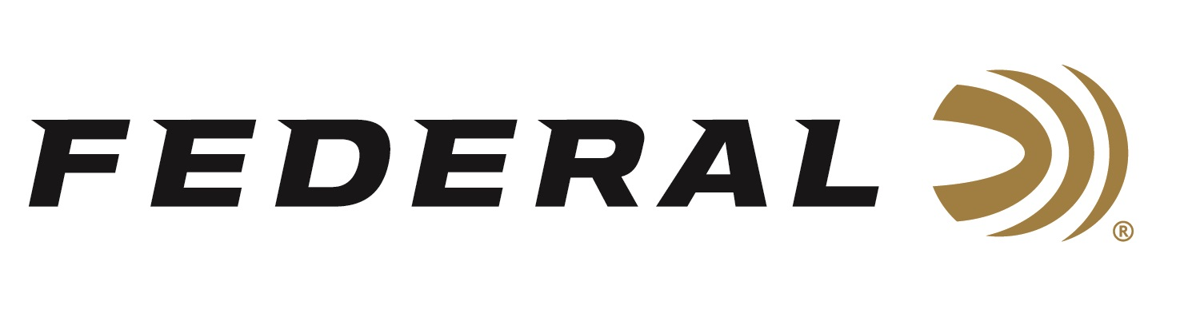

FOR IMMEDIATE RELEASE

World Champion Josh Froelich Appears on “It’s Federal Season” Podcast

ANOKA, Minnesota – July 16, 2020 – In 2018, Federal’s sponsored shooter Josh Froelich enters his first IPSC Shotgun World Shoot in France. After six days and thirty stages, Froelich wins the Open division and leaves a World Champion. It was his first time representing the United States and the last time he would shoot an IPSC competition. In the latest episode of the “It’s Federal Season” podcast, hear more about Josh’s story on competitive shooting, what drives him to compete, and where his firearms passion began.

“Federal is fortunate to have Josh as one of our ambassadors,” said Jason Vanderbrink, Federal Ammunition’s President. “His enthusiasm to teach the shooting sports games or teach new shooters to responsibly own and operate a firearm is in line with Federal’s mission.”

In this episode, Froelich gives some great advice on shooting a match for the first time and how experienced shooters can draw more first-time shooters into the firearm community with safe and fun recommendations.

In the Tech Talk segment, Josh Froelich runs down his firearms of choice, the ammo he uses and the accessories that make him an unstoppable force at any competition he enters. Before signing off, find out what promotions are available for consumers to buy Federal products and merchandise.

Episode No. 10 - World’s Best
https://www.federalpremium.com/podcast.html

Look for more episodes at www.federalpremium.com or where you find your favorite podcasts.

Federal ammunition can be found at dealers nationwide or purchased online direct from Federal. For more information on all products from Federal or to shop online, visit www.federalpremium.com.

Press Release Contact: JJ Reich
Senior Manager – Press Relations
E-mail: VistaPressroom@VistaOutdoor.com

About Federal Ammunition
Federal, headquartered in Anoka, MN, is a brand of Vista Outdoor Inc., an outdoor sports and recreation company. From humble beginnings nestled among the lakes and woods of Minnesota, Federal Ammunition has evolved into one of the world's largest producers of sporting ammunition. Beginning in 1922, founding president, Charles L. Horn, paved the way for our success. Today, Federal carries on Horn's vision for quality products and service with the next generation of outdoorsmen and women. We maintain our position as experts in the science of ammunition production. Every day we manufacture products to enhance our customers' shooting experience while partnering with the conservation organizations that protect and support our outdoor heritage. We offer thousands of options in our Federal Premium and Federal® lines-it's what makes us the most complete ammunition company in the business and provides our customers with a choice no matter their pursuit.

